

|  |  |
| --- | --- |
|  | **PORTUSplus_the online Journal of RETE**  **N. 6, March 2016, Year VI**  **RETE Publisher, Venice, ISSN: 2039-6422** |
|  |  |
| **ABSTRACT**  The port of Tangier is about to become one of the most dynamic ports across the Euro-Mediterranean area. The valuing of exceptional locational qualities as maritime crossroads between international shipping routes (Gibraltar Straits) occurs in a context of exacerbated rivalries among Mediterranean transhipment hubs (e.g. Algeciras, Valencia, Cagliari, Gioia Tauro, Taranto, and Marsaxlokk). Locally and regionally, it is made possible through the physical separation between the port city of Tangier and the new multifunctional site of Tangier Med, located 30 km eastwards. This paper recalls briefly the main historical steps of Tangier’s development since its origins. Then, it reviews its recent evolution on three different geographic levels: the one of maritime flows and international port competition, the one of regional integration of Tangier in the Moroccan and Maghreb transport systems, and the local issues of port-city redevelopment both within the traditional city and at the new site of Tangier Med. Some concluding remarks aim at linking together these three levels of analysis in terms of the possible futures of this ambitious project.  (**P_abstract**, Lucida Sans 10pt, alignment left)  **Title**_In English  **Abstract**_In English_Max. 1.500 characters (spaces included) | Maghreb port cities  in transition: the case of Tangier (**P_title**, Lucida Sans 21pt, alignment left)  César Ducruet1, Fatima Zohra Mohamed-Chérif2, Najib Cherfaoui3 (P_author, Lucida Sans bold 11pt, alignment left)  1 Centre National de la Recherche Scientifique (CNRS), UMR 8504 Géographie-Cités, University of Paris-I Sorbonne, 13 rue du Four, F-75006,Paris  2 Ecole Nationale Supérieure Maritime, Bou Ismail, Algeria  3 Ponts et Chaussées, Casablanca, Morocco (**P_affiliation**, Lucida Sans 11pt, alignment left)  ducruet@parisgeo.cnrs.fr, medcherif.fz@gmail.com, cherfaoui122005@yahoo.fr (**P_adress mail**, Lucida Sans 11pt, alignment left) |
|  |  |
| **KEYWORDS** (**P_keywords,** Lucida Sans bold 13pt, alignment left)  **Hub port; Maghreb; Morocco; Mediterranean;**  **Port city; Redevelopment** | |

Maghreb port cities in transition: the case of Tangier (**P_title**, Lucida Sans 21pt, alignment left)

Introduction (P_title paragraph, Lucida Sans bold 13pt, alignment left)

Recent decades have witnessed important changes in port-city relationships such as the widely known functional and spatial separation between port and urban activities. Countless studies of waterfront redevelopment have appeared since the 1950s throughout the professional and scientific literature, while some geographers have synthesized port-city dynamics in their spatial models (Bird, 1963; Hoyle, 1989). The strong focus on inner city issues (waterfront) and the Western-centric dimension underlying most approaches have led to the conclusion that port and urban functions are incompatible nowadays. However, among the wide diversity of port-city trajectories is the strengthening of port activities on the level of city-regions (Ducruet and Lee, 2006). In the Asia-Pacific region, many hub port cities combine rather than separate port and urban functions (Lee et al., 2008).

(**P_text**, Lucida Sans 10pt, justified)

This paper proposes to interpret recent developments at Tangier (Morocco) as part of a wider trend defined by the emergence of multilayered hubs at strategic locations. Many countries and cities are engaged in such hub strategies integrating logistical, free-zone, and urban functions, which clearly illustrates the continued importance of material flows in local and regional development (Hesse, 2010). Tangier may thus be analysed in the light of recent works on Busan (Frémont and Ducruet, 2005) and Incheon (Ducruet, 2007) in South Korea, but also Port Said (Bruyas, 2000), Dubai (Jacobs and Hall, 2007), Hong Kong and Singapore (Lee and Ducruet, 2009), among other. All describe how local and global forces combine to give birth to a new type of port cities exploiting economies of scale (containers) but also port-related intermodalism, logistics, renewed hinterland connections, while also inducing local transformations of the socio-economic system.

The case of Tangier is believed to contribute to a general reflection about the territorial impacts of multilayered hubs. The very ambitious multifunctional project (Tangier Med) which operations started in 2007 aims at exploiting economies of scale for large containerships (transhipment hub) regionally while attracting value-added and skills locally and nationally through industrial and logistics parks. Physical separation from the traditional city of Tangier does not contradict the latter’s reinforcement of cruise activities for passengers. This paper proposes a historical perspective about the development of this port city, followed by a review of the regional context of hub port competition, and the response brought by current projects. Beyond the port city issue itself, we thus look at complementary aspects such as the specific identity conferred by the border to Tangier (Piermay, 2009). Other aspects such as the history of port development and port operations in Morocco and Tangier are well documented thanks to recent extensive research (Cherfaoui and Doghmi, 2003, 2005). This paper would also like to complement the relative scarcity of specific studies on Tangier by offering a synthesis of port and urban dynamics at stake in recent years.

Historical background on Tangier (Tingis) port city

The Tangier peninsula refers to a large area of Morocco prolonged towards Spain forming a trapeze of 50 kilometers on the North side (Gibraltar Straits) and 120 kilometres at its base, running North-South across 60 kilometres (Figure 1).



*Figure 1. Aerial view of Gibraltar Straits with the bay and port of Tangier in 1967.*

*Sebta and Oued R’mel are the current sites for the development of Tangier Med.*

(**P_caption**, Lucida Sans 8pt, centred)



*Figure 2. Spatial evolution of Tangier port, 1903-2010.*

Prior to its reunification by Sultan Moulay Ismail (17th century), this peninsula has been under multiple influences and was occupied by various foreign powers: Phoenicians (5th century BC), Romans (1st century AD), Vandals, Byzantines, and Visigoths (5th century AD), Arabs (7th century AD), Portuguese (15th century AD), Spanish (16th century AD), and British (17th century AD). This exceptional site has often been the target of external threats, invasions, resistance and continuous rivalries. But it has also been the birthplace of explorer and geographer Ibn Batouta (1304) from where he travelled during 28 years up to Beijing, Samarqand, and Timbuktu. During the 14th century, Tangier is a dynamic port city trading various commodities with Marseilles, Genoa, Venice and Barcelona.

The first ambitions to strengthen Tangier’s port as cargo hub and against natural threats arose in the 17th century under British rule. Tangier became a “diplomatic” gateway in the 19th century under Arab rule, while its port activities gain from the decline of neighbouring Tetouan due to the increase of ship sizes and the advent of steam sailing. At the end of the 19th century, Tangier’s port traffic superseded those of Casablanca and Mogador, welcoming about 1,750 vessels on average each year. Modern expansion plans were conferred in 1914 to the Société Internationale de Tanger but effectively started only in 1925 due to World War I. Such plans allowed the port to embark on larger-scale operations gradually (Figure 2), while developing its landside connections with the hinterland. The new Tangier-Fes railway was inaugurated in 1927, linking the port city with Tetouan, Larache, and other large northern cities also by road. The idea of a fixed link across Gibraltar Straits emerged at that period and went through series of feasibility studies by French and Spanish engineers about the right project to apply (e.g. tunnel, bridge) before vanishing away at the eve of the 1990s. From the early 1900s, Tangier’s port is superseded by Casablanca’s traffic: the remoteness from Morocco’s core economic regions as well as the relative limitation of the border have both played a role in such phenomenon besides the lack of adequate port and hinterland infrastructures. Such trends have resulted in a faster development of the city compared with the port along the century; the concentration of residential and service activities along densely populated and narrow streets formed an urban belt accelerating land pressure and congestion.

This impact of remoteness mostly derives from the State’s perception of this location. The border has long been seen as a barrier rather than a gateway or potential corridor. It has taken decades before the exceptional situation of Tangier (a crossroads between world’s busiest maritime routes) has been seen as an opportunity, beyond the simple idea of being a transit point. Changes in policies appeared around 1993, with the idea of catching transit traffic in addition to domestic needs. A first project of a transhipment hub port was proposed on the Atlantic near the city of Asilah, but this “Tangier Atlantic” project was finally cancelled in 1999. In the context of balanced liberalism and state interventionism from the advent of King Mohamed VI (1999), the country opts for modernisation and globalisation (Piermay, 2009). In the port sector, the estuary of Oued R’mel (nearest point from Europe in front of Tarifa) is chosen for hosting the new project of Tanger Med launched in 2002. Parallel to the ambition catching transit trade flows between external regions, this project notably aims at relieving Tangier from urban pressure.

Tangier Med: transport infrastructure and tool for regional planning

(**P_title paragraph**, Lucida Sans bold 13pt, alignment left)

Tangier in the Mediterranean and Moroccan port systems

(**P_subtitle paragraph**, Lucida Sans italic 13pt, alignment left)

Numerous studies have well documented and analysed the evolution of the West Mediterranean port system, highlighting the strong concentration of container traffic from the 1990s onwards due to the emergence of transhipment hub ports (Ridolfi, 1999; Zohil and Prijon, 1999; Fageda, 2000; Foschi, 2003). The comparative study of Ducruet (2010) between North European and South European ports showed the drastic increase of the liner shipping network’s concentration in the South. While North European ports (i.e. the so-called North European range from Le Havre to Hamburg) are engaged in the servicing of vast continental hinterlands, Southern ports tend to serve narrower hinterlands that are more local in scope, notably due to the limited railway accessibility (Gouvernal et al., 2005) and the comparative cost advantage Northern ports in terms of land transport. One of the possible strategies proposed for Southern ports was to develop European Distribution Centres (EDCs) in order to better exploit their proximity to inland markets (Ferrari et al., 2006). Another strategy was the cooperation amongst neighboring ports through the valuing of regional port clusters (Notteboom, 2009). However, such strategies may not be directly transferable to Maghreb ports and notably Tangier.

A look at recent traffic figures (Figure 3) confirms that Tangier still plays a secondary role nationally. This is due to a majority of general cargo flows that are less weighty than bulks handled at most other Moroccan ports, such as phosphates at Casablanca and Jorf Lasfar. Until the decreasing trend striking national traffic evolution in 2008 and 2009, probably due to the impact of the global financial crisis, the share of Tangier in national traffic has never ceased to expand at a reasonable pace, from 4% to 7% of total traffic[1]. The impact of the Tangier Med project is, of course, not yet visible although recent figures show an explosion of traffic at the new terminals during the first development phase. Also in Figure 3, we see that Tangier is among the ports having the most stable growth rates during the period 1995-2001, together with Casablanca and Safi[2]. For the period 2002-2008, traffics have more fluctuated in the whole port system probably due to the country’s liberal policy towards openness.

On the level of the Mediterranean basin, higher traffic growth among top container ports is observed at Eastern locations. Marsaxlokk, Malta’s transhipment hub port has the highest growth rate among West Mediterranean ports. Recent studies of Maghreb-related liner shipping networks could have highlighted the very strong role of this hub for servicing several Maghreb ports by feeder links, together with Algeciras (Ducruet, 2009). However, the limitations faced by those hubs in terms of operational costs and congestion have offered new opportunities for smaller ports to develop transit functions and compete in this rapidly evolving market. While Algeria and Tunisia are now engaged in building their own hubs of Djen Djen and Enfidha respectively, those projects seem to remain too much port-centric without offering a wide diversity of accompanying services (e.g. logistics, intermodal facilities) such as in Tangier. Another limiting factor for these projects is the governance: Morocco has run a port reform[3] decentralising decision-making towards port authorities and opened the door to European global players such as CMA-CGM, MSC, and Maersk Line, while Djen Djen and Enfidha are still heavily controlled by central governments and benefit from the nowadays weakened Dubai Ports World (DPW).

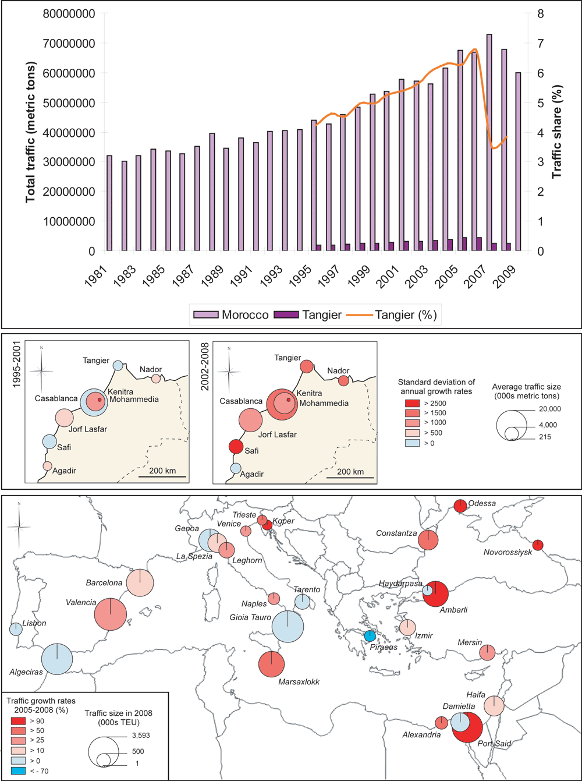

*Figure 3. Traffic dynamics on various levels (Source: Port of Hamburg website; Port Authorities)*

*The Tangier Med project* (**P_subtitle paragraph**, Lucida Sans italic 13pt, alignment left)

Tangier Med is a deep-sea port whose construction has started in 2004 and which started its operations in July 2007. Situated 40 kilometres East of Tangier city it also locates near the Spanish enclave of Ceuta. Its traffic is destined for 85% to transhipment and for 15% to domestic demand (import-export). One of the goals of the project is to strengthen the regional economy while countering illicit trade activities as it has been the case so far with the position of gateway to Europe (Planel, 2009). The articulation between the local and the global economy would foster economic development and job creation as a means relieving the region from “misery, drug traffic, slums of Beni Makada and the pateras which led thousands of young people to death” (Troin, 2006).

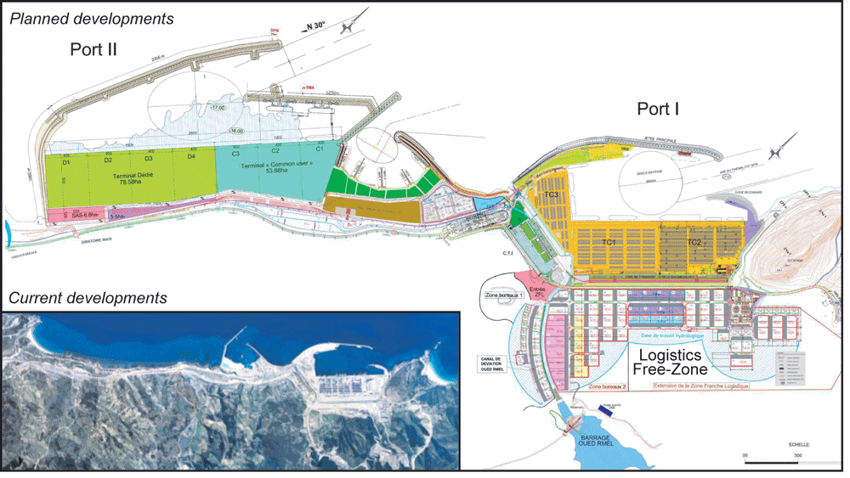

*Figure 4. Overall land use of Tangier Med project (Source: adapted from Port Authority)*

This port is able to welcome latest generation container vessels, with a water depth of 16 meters, a total quay length of 1600 metres, and a capacity of about three million TEUs (Figure 4). The first development phase (Port 1 in the figure) costs one billion euros, while the second phase (Port 2) should be operational in 2012 with a capacity of five million TEUs, reaching a total of eight million TEUs capacity on a yearly basis. Between the two terminals of Tangier I and Tangier II is located the passenger port that is planned to start its operations in July 2010, focusing on seven million passengers and two million vehicles a year. Its location allows reducing the crossing to and from Algeciras to one hour only, while the ships should realise five rotations a day instead of only three when connecting Tangier city. The first links of the passenger port are planned to connect firstly Algeciras, and to reach by ferry several other destinations such as Sete, Barcelona and Genoa from October.

Through the concessions of several global shipping lines as mentioned earlier, traffic has grown steady already in 2010 with a total of one million TEUs reached by June. As early as its conception, the project has been considered not only as new port infrastructure but also as an integrated project going beyond the sole cargo handling and hub functions. Plans claim that the project should create about 120,000 new jobs in the region of which about 20,000 for the port itself and the rest in the free-trade zones, counting on the project’s attractiveness towards multinational firms for shorter transit time and low cost workforce.

*Tangier Med territorial development* (**P_subtitle paragraph**, Lucida Sans italic 13pt, alignment left)

Free-zones and the new city(**P_subtitle 2 paragraph**, Lucida Sans 11pt, alignment left)

Territorial development has been defined by the authorities as a process directly derived from the creation of large free-trade zones around port areas, as seen in several other new generation port cities such as Incheon in South Korea, largely relying on foreign capital for its development (Ducruet, 2007). These commercial and industrial zones are complemented by additional hinterland connections and the creation of a new city (Figure 5). The logistics-free zone besides the new port covers about 100 hectares and includes activities such as logistics, post-manufacturing (assembly, packaging), and distribution (warehousing and bundling-unbundling). One of the two industrial zones is located in the rural local authority of Melloussa, in the heart of the peninsula, 20 kilometres south of the port. The second industrial zone located 10 kilometres from Tangier is dedicated to Renault factory, which should become operational by 2012, with a production of about 170,000 to 400,000 vehicles a year. This project shall generate 4,000 jobs directly and other indirect activities through subcontracting, for an expected total of 24,000 jobs. The position of Tangier with regard to other South European industrial basins constituting around 30 assembly units within a radius of 72 hours, shall also become advantageous for Tangier project itself in terms of potential shifts and further subcontracting. An important aspect of the project is the partnership between Renault and Veolia supporting a green policy; the industrial project will optimise energy consumption, the use of renewable energies, hoping to suppress carbon emissions, chemical spills, and recycling all industrial waste products. Finally, the free-trade zone is planned to locate in Fnideq (Tetouan province) for welcoming 20 hectares of office space and 500 companies.



*Figure 5. Hinterland structure of Tangier Med (Source: TMSA, Port Tangier Med)*

This last example of Fnideq is revelatory of the fact that this peninsula has always been, to some extent, a free-trade area. The urban area of Fnideq located near the Sebta region is a true emporium through which contraband goods transit from Spain. It is also where Moroccan fresh products transit before reaching Sebta. Fnideq remains a largely unplanned city functioning as commercial entrepôt connecting an important share of the entire province’s distribution network. Before current policies made it official, Fnideq was virtually and already a fast-growing free-trade city, expanding from 3,500 inhabitants in 1963 to 13,613 (1982) and 34,486 (1994). In such respect, the Tangier Med project only prolongs established dynamics. It is even not very clear what will be the relation between existing free-trade and the zone under construction. The importance of Fnideq is such that one may even argue that the new free-zones will depend on its consent to prosper. Some local entrepreneurs may not like to see new entrants in the zones nearby competing with their commerce. Finally, the new city of Charafate has been conceived for answering directly the congestion problems of Tangier city[4] and anticipating the housing demand to be generated by the rapid influx of labour and their relatives. So as to preserve coastal amenity, the new city will be built inland between Tangier and Tetouan; it is planned to spread over 1,300 hectares and to host more than 150,000 inhabitants with a potential of 30,000 housing units.

More recently, four new special zones have been announced for the next years in the Straits region as well as the extension of Tangier Med zone itself, totalling 925 hectares of land area and 1.2 billion dirhams over three years. Among the planned zones whoe development starts in 2010 are Tetouanshore and the industrial free zone of Charafate+. The latter’s site is located nearby the Renault Tangier Med zone, will cover 300 hectares, and will specialise in the automobile sector (parts, logistics operations, subcontracting, related services). The first phase covering 60 hectares shall be realised in late 2012. In 2011 will start the construction of the Souq Lakdim industrial zone (150 hectares), located 15km from Tetouan and specialised in industrial and logistics activities, as well as the extension of Tangier Free Zone (100 hectares additionally). Finally, in 2012 will start the bulding of Fnideq commercial zone over an area of 140 hectares welcoming wholesale and retail activities.

Integration of logistical aspects

The new port complex is linked to the rest of the peninsula by means of communications networks including highways (61 kilometres connecting the Northern highway Rabat-Tangier; 35 kilometres connecting with Asilah), expressways (transforming local roads connecting Tetouan; a new infrastructure connecting Fnideq), and a new railway line (45 kilometres). Such developments imply that on a national level, the port of Casablanca should not be anymore the main port for the country. As history rewrites itself, Tangier Med marks a turn in Morocco’s coastal restructuring (Chouiki, 2009). The natural hinterland of Tangier will continue to be local in scope, but for other traffics originating fro Asia for instance. It may be the case that traffics with Europe and North Atlantic in general will remain bound to Casablanca due to the resistance of Moroccan shippers and freight forwarders for whom direct calls at this port are important.

Yet, contrary to such expectations, the most likely scenario nationally is the increasing role of Tangier as domestic hub for other Moroccan ports. Indeed, the maritime transport cost for one TEU between Tangier and Casablanca is about 400 dirhams (using 600 TEU feeder vessels) and reaches 4,000 dirhams using road or rail transport inland, notwithstanding negative environmental externalities in the case of trucking. Thus, there should not be high competition between the two ports: Casablanca may continue to be the main load centre of the country concentrating about 80% of container traffic, while Tangier would become a distribution centre transhipping Casablanca’s containers among others.

The reconversion of Tangier port city

The port of Tangier city is about to be reconverted into a marina. In such respect, the project plans the extension of existing port infrastructure (quays) in order to be able to welcome large cruise ships of 200 metres long (see Figure 6). The insertion of Tangier city in cruise services shall increase local benefits (taxes and visitors), the city’s image and employments. An international contest has been launched and the project is currently under study. It plans a large public space in the continuity of the jetty with the recuperation of 30 hectares, and the support of traditional fishing activities that are closely related to the identity of the port city.

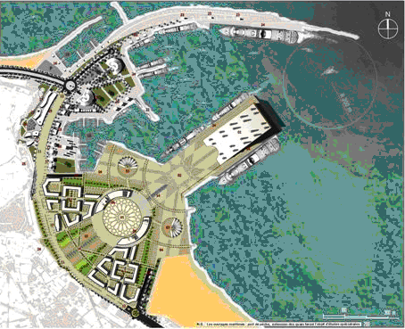

*Figure 6. Planned reconversion of Tangier port city (Source: Port Authority)*

This project is part of a wider national policy favouring cruise tourism, profiting from the high growth of this sector in European markets. Indeed, the country is a privileged destination for European tourists: it is the first destination among North African countries in terms of tourism attractiveness. Nevertheless, competition is fierce, notably from neighbouring ports such as the Canary Islands and Andalousia. In the end, Tangier city wishes to value its historical role as first destination city in the 1960s, since its position is nowadays only fourth after Marrakech, Agadir and Casablanca. Several other factors have contributed to this state of affairs, such as the limited domestic and international flight connections, the high pollution of the bay of Tangier, and the downgrading of the city’s hotel sector.

Conclusion

The Tangier Med project has been planned for responding to global demand (transhipment hub functions) but this does exclude local dynamics of economic growth and employment creation, while paving the way towards a better regional balance within the country as a whole. Three main directions define the project: competitiveness, territorial balance, and local development. Such directions are not entirely new in the region; one may recall earlier “waves” of development such as across Southern Europe in the 1970s where several port sites became the focus of ambitious port-related industrial developments based on the concept of growth pole (heavy industries) and largely inspired from Northern counterparts (e.g. Benelux). Many of these projects did not reach their goals in a context of global oil crisis and global shift, but almost all of them have again been the focus of container hub developments in the 1990s (e.g. Gioia Tauro, Tarento, Sines, Algeciras, Fos, etc.). Other examples, of course, include the Asian free-zone models, which encountered very diverse outcomes and are still evolving nowadays. Whether the new generation of port cities to which Tangier seem to belong will be truly successful remains to be seen. Externally, it responds rather successfully to regional competition from other hubs, in a Euro-Mediterranean context where other Maghreb hub port projects do not seem to have comparable status and diversity to offer. Internally, its socio-economic impact is so far relatively important, measured by actual job creation and the current diversification of the local and regional economy, in an area traditionally marked by low productivity agriculture and social exclusion. Despite the extravert character of such projects, job creation at port areas and free-zones and by tourism activities is likely to reduce poverty rate of rural populations in a medium-term perspective.

**The tables and the illustrations should be included preferably in their respective paragraph.**

**For the creation of tables as a word file, please follow the example below, as closely as possible.**

*Table 1. Caption (Source or Copyright: ……………………………)*

(**P_table**, Lucida Sans bold 9/Lucida Sans 9, centred)

|  |  |  |  |  |  |
| --- | --- | --- | --- | --- | --- |
|  | **Reference**  **data** | **Data 9/5** | | **Data 27/7** | |
| Diffusion (%) | Intensity (%) | Diffusion (%) | Intensity (%) |
| Survey  n.1 | 0-100 | 29,3 | 0,9 | 45,3 | 40 |
| Survey  n.2 | 0-50 | 4,9 | 13 | 31,9 | 27,7 |
| Survey  n.3 | 0-30 | 12,7 | 2,7 | 22,7 | 0,8 |

**For the notes on the tables use the style “P_table”**

**As for the illustrations it is also possible to add graphic charts (possibly made in Excel), photographs and drawings.**

*Figure 1. Title (Source or Copyright: ……………………………)*

|  |
| --- |
| GRAPHIC OR DRAWING |

**Bibliography** (**P_title references**, Lucida Sans bold 11pt, alignment left)

(**P_text**, Lucida Sans 9pt, alignment left)

Assayag, I.J. (2000) Tanger, regards sur le passé.

Bibliothèque Communale de Casablanca (1904-1964) Fonds documentaire.

Bird, J. (1963) The Major Seaports of the United Kingdom, London, Hutchison.

Bruyat, F. (2000) Port Saïd (Egypte), lieu d'articulation du local au mondial. Zone et ville franche : questions d'échelles, Annales de Géographie, 612, 152-171.

Bulletins Officiels (1912-2005) Décembre à Juin.

Cherfaoui, N., Doghmi, H. (2003) Systèmes portuaires, un tour du monde, Sciences de l’Ingénieur, Casablanca, Maroc.

Cherfaoui, N., Doghmi, H. (2005) Ports du Maroc des origines à 2020, Sciences de l’Ingénieur, Casablanca, Maroc.

Chouiki, M. (2009) Le port de Tanger Med : un tournant dans les dynamiques de restructuration des littoraux au Maroc, in : Semmoud, B. (ed.), Mers, Détroits et Littoraux : Charnières ou Frontières des Territoires, L’Harmattan, Paris.

Ducruet, C. (2007) Incheon, showcase of South Korea and Seoul’s mask, Mappemonde, 85(1), <http://mappemonde.mgm.fr/num13/articles/art07102.html>

Ducruet, C. (2009) Port competition and foreland specialization at Maghreb container ports, Colloque international, Les ports du Maghreb : entre volonté et réalité, Ecole Nationale Supérieure Maritime, Algérie.

Ducruet, C. (2010) Reti marittime e gerarchie portuali in Europa: un confronto tra Nord e Sud, L’Ingegnere, 37 (in press).

Ducruet, C., Lee, S.W. (2006) Frontline soldiers of globalization: port-city evolution and regional competition, Geojournal, 67(2), pp. 107-122.

Dyé, A.H. (1908) Les ports du Maroc, Bulletin de la Société de Géographie, Paris, France.

Fageda (2000) Load centres in the Mediterranean port range: ports hub and ports gateway, Paper presented at the 40th Congress of the European Regional Science Association, Barcelona, Spain, 29 August-01 September.

Ferrari, C., Parola, F., Morchio, E. (2006) Southern European ports and the spatial distribution of EDCs, Maritime Economics and Logistics, 8(1), 60-81.

Foschi (2003) The maritime container transport structure in the Mediterranean and Italy, E-papers del Dipartimento di Scienze Economische, Universita di Pisa, Discussion Paper 24.

Frémont, A., Ducruet, C. (2005) The emergence of a mega-port, the case of Busan, from the local to the global, Tijdschrift voor Economische en Sociale Geografie, 96(4), 421-432.

Gouvernal, E., Debrie, J., Slack, B. (2005) Dynamics of change in the port system of the Western Mediterranean, Maritime Policy and Management 32(2), 107-121.

Hadrami, A. (2005) Port de Tanger, images d’une évolution, manuscript.

Hesse, M. (2010) Cities, material flows and the geography of spatial interaction: urban places in the system of chains, Global Networks, 10(1), 75-91.

Hoyle, B.S. (1989) The port-city interface: trends, problems, and examples, Geoforum, 20(4), 429-435.

Jacobs, W., Hall, P.V. (2007) What conditions supply chain strategies of ports? The case of Dubai, Geojournal, 68(4), 327-342.

Lee, S.W., Ducruet, C. (2009) Spatial glocalization in Asia-Pacific hub port cities: a comparison of Hong Kong and Singapore, Urban Geography, 30(2), 162-184.

Lee, S.W., Song, D.W., Ducruet, C. (2008) A tale of Asia’s world ports: the spatial evolution in global hub port cities, Geoforum, 39(1), 372-385.

Légation Américaine à Tanger, Fonds documentaire couvrant le XVIIème siècle.

Lemarchand, A., Joly, O. (2009) Regional integration and maritime range, in Notteboom, T.E., Ducruet, C., De Langen, P.W. (Eds.) Ports in Proximity: Competition and Coordination Among Adjacent Seaports, Aldershot, Ashgate, pp. 87-98.

Mohamed-Chérif, F.Z. (2010) L’insertion territoriale du nouveau port Tanger Méditerranée, Colloque international, Les ports du Maghreb : entre volonté et réalité, Ecole Nationale Supérieure Maritime, Algérie.

Notteboom, T.E. (2009) Path dependency and contingency in the development of multi-port gateway regions and multi-port hub regions, in Notteboom, T.E., Ducruet, C., De Langen, P.W. (Eds.) Ports in Proximity: Competition and Coordination Among Adjacent Seaports, Aldershot, Ashgate, pp. 55-72.

Piermay, J.L. (2009) La frontière, un outil de projection au monde. Les mutations de Tanger (Maroc), Espaces et Sociétés, 138(3), 69-83.

Ridolfi (1999) Containerisation in the Mediterranean: Between global ocean routeways and feeder services, Geojournal 48(1), 29-34.

Timoule, A. (1988) Le Maroc à travers les chroniques maritimes, Vol. 1-2, Ed. Sonir, Casablanca, Maroc.

TMSA (2005) Projet Tanger Méditerranée, Note de présentation, Tanger, 7 p.

Troin, J.F. (2006) Le Grand Maghreb, Armand Colin, Paris.

Planel, S. (2009) Transformations de l’Etat et politiques territoriales dans le Maroc contemporain, in : Bouquet, C. (Ed.), L’Etat en Afrique, Espace Politique, n°7.

Zohil, J., Prijon, M. (1999) The MED rule: the interdependence of container throughput and transshipment volumes in the Mediterranean ports, Maritime Policy and Management, 26(2), 175-193.

1. Port traffic statistics for Tangier were available only from 1995. (**P_footnotes page**, Lucida Sans 8pt, alignment left)
2. Lemarchand and Joly (2009) have notably demonstrated the inverse relationship between average traffic size and standard deviation of growth rates on a given period and for a given set of ports, in their study of regional integration and maritime ranges.
3. The port reform (law 15-02) excludes of its field of application the port of Tangier Med (article 32), so that the reform does not apply to the port situated within the special development zone of Tangier Med, which was created by the law bill no. 2-02-644 (10th September 2002). Moreover this bill exempts this zone from any tax (articles 12 and 13).
4. About 60% of immigrant flows are coming from outside the province, accentuating the pressure and fostering the demand for additional housing and services.